Videos are online on how to clone and create repositories.

For program 2, I have created a repository and added your team to the repository as developers.

Pick one member of your team to set up the repository. I am using a team repository of teamxx.

Open visual studio and click team explorer.

Click the connect icon (next to the home)

Click new in the dropdown list under “local git Repositories”

Fill in your team name for where to store the repository.

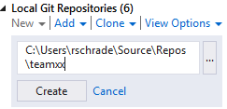

Create a vs solution.

Now create a solution named prog2 that resides in the repository above. This is the same way that we created our homework solutions and program 1 solutions.

Add in all the files your group is going to have (Prog2.cpp, srt.h, menu.h are required.)

Add in other files like srt.cpp menu.cpp or a variation of other files, see examples in program 2 writeup.

Prog2.cpp should include both srt.h and menu.h

Keep your files well organized. Place srt member functions together and do not mix other functions with them.

Place the class declaration for the menu in menu.h

Place the class declaration for the srtList in srt.h

Commit this to your local repository and then push to the remote server.

When you commit, make sure and add the files in the changes section so they move to the staged changes.

When pushing to the remote server, copy the https link. It should be similar to:

<https://gitlab.mcs.sdsmt.edu/csc215s18prog2/teamXX.git>

The other team mates do the following.

Cloning the repository.

Open visual studio.

Click team explorer.

Click the connect icon (next to the home)

Click the clone under “local Git Repositories”

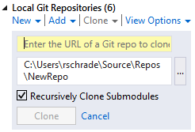

Fill in the url from gitlab.

Should resemble: <https://gitlab.mcs.sdsmt.edu/csc215s18prog2/teamXX.git>

Where XX is your team number

Make sure you note where the project is being placed.

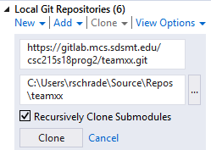

Click the clone button.